**HW 3 Report**

**Part - 1**

Accuracy score after training logistic regression model keeping all parameters and hyperparameters as default.



Confusion matrix –

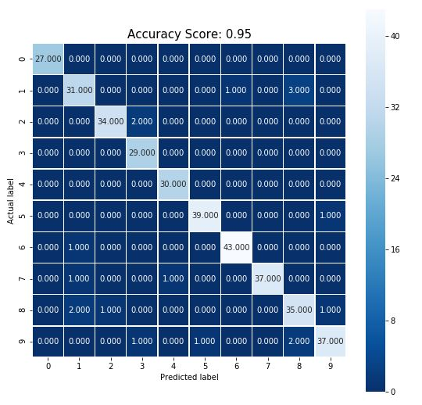

### After Training L2 regularized model and tuning hyper parameter "C" using K-fold Cross validation

### 

### After Training L1 regularized model and tuning hyper parameter "C" using K-fold Cross validation

### 

**Part – 2**

Multiclass logistic regression model

Tensor board –

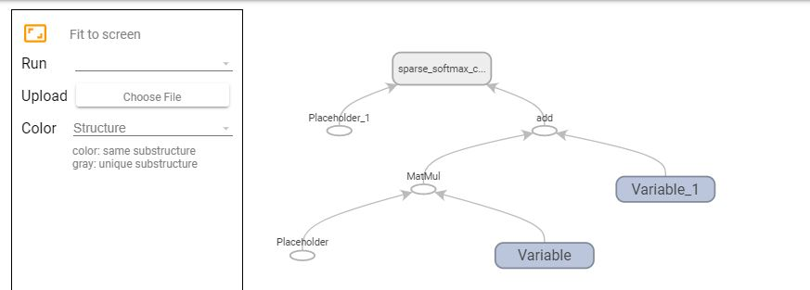

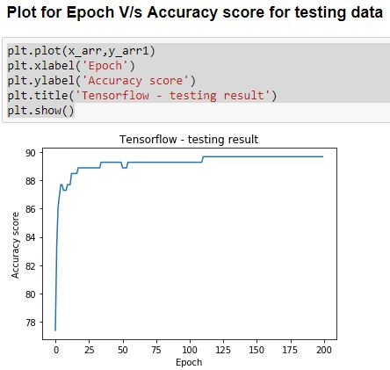

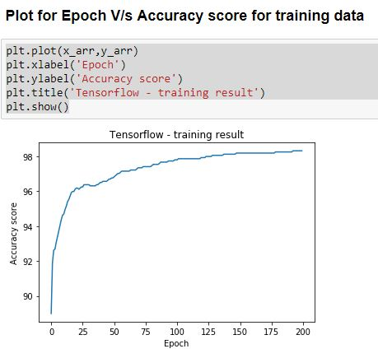

Dense neural network model

Tensor board –

